**Habitat, fishing and biodiversity control grazing potential on coral reefs**

**Authors**

James PW Robinson1, Jamie M McDevitt-Irwin2, Jan-Claas Dajka1, Jeneen Hadj-Hammou1, Samantha Howlett1, Alexia Graba-Landry3, Andrew S Hoey3, Nicholas AJ Graham1.

**Affiliations**

1. Lancaster Environment Centre, Lancaster University, Lancaster, LA1 4YQ, UK
2. Stanford University, Hopkins Marine Station, Pacific Grove, CA 93950
3. ARC Centre of Excellence for Coral Reef Studies, James Cook University, Townsville, Queensland 4811, Australia

Potential Journals:

* Global Ecology and Biogeography
* Functional Ecology
* Ecological Applications
* Coral Reefs

**Keywords**

functional ecology, herbivory, fishing, bottom-up, top-down, biodiversity, grazing, benthic

**Abstract**

**Introduction**

Herbivory is crucial to ecosystem function and community structure across terrestrial and aquatic ecosystems, playing a key role in cycling nutrients (Metcalfe et al. 2014), regulating species diversity and productivity (Royo et al. 2010, Prieditis et al. 2017), and controlling habitat regime shifts (Zimov et al. 1995; Hughes et al. 2007; Keesing and Young 2014). Herbivory processes are generally measured at local scales relevant to individual behaviours and population sizes, which restricts our understanding of how ecosystem functions operate across scales. Furthermore, anthropogenic pressures typically impact ecosystem processes, including herbivory, across much larger areas (ref, Wather et al. 2010?). Therefore, developing our understanding of both natural and anthropogenic drivers on herbivory at large scales requires the integration of fine-scale herbivory observations with macroecological datasets. Such analyses are particularly relevant for coral reef ecosystems, which are facing multiple damaging human pressures and where herbivory is a key ecosystem function (Hughes et al. 2007; Ledlie et al. 2007; Cheal et al. 2010).

On tropical coral reefs, top-down control of algae and promotion of calcifying coral taxa are key functions primarily performed by a diverse guild of herbivorous fishes (Bellwood et al. 2004). Within this group, observations of grazers’ feeding morphology and behaviour have been used to categorise species into two distinct grazing functions: cropping and scraping (Bellwood and Choat 1990; Polunin et al. 1995; Green and Bellwood 2009). Cropping species target filamentous turf algae, which promotes coral settlement and growth by maintaining cropped algal states (Arnold et al. 2010). Scraping species graze dead coral substrate to consume microscopic epiphytes and epilithic and endolithic phototrophs (Choat and Clements 2018). By removing detritus and epilithic algal matrix (EAM), scrapers promote coral recruitment by clearing settlement space (Bonaldo & Hoey 2014). Combined, cropping and scraping are considered essential functions which help sustain coral-dominated states (Bellwood et al. 2004).

Mature algae can proliferate in the absence of sufficient grazing pressure (Mumby et al. 2006; Burkepile and Hay 2008), and correlative analyses of fished reef ecosystems have provided evidence of grazing biomass thresholds below which reefs become algae dominated (Graham et al. 2015; Jouffray et al. 2015; Robinson et al. 2018). Herbivorous fish populations are overexploited across much of the tropics (Edwards et al. 2014), which has compromised grazing functions on reefs which fail to maintain herbivore biomass thresholds (Bellwood et al. 2011, Graham et al. 2015, Robinson et al. 2018). However, fishing effects can be compounded by bottom-up influences of the environment/habitat on herbivore assemblages (Russ et al. 2015), whereby species-specific habitat associations produce spatial structuring of herbivore populations among different habitat types (Hoey & Belwood 2008; Doropoulos et al. 2013) and benthic compositions (Hoey & Bellwood 2011; Heenan et al. 2016). Bottom-up influences of fish populations may be particularly strong when fish rely on habitat for both structure and food, such as algal cropping fishes which are generally small and particularly dependent on the reef matrix for shelter (Wilson et al. 2008). Thus, herbivore assemblage structure are often mediated by both habitat composition and fishing intensity but links between these drivers and grazing functions are not well resolved, particularly at macroecological scales.   
 Patterns in herbivore biomass are widely used to imply changes in herbivore functioning on coral reefs (e.g., Nash et al. 2016; Robinson et al. 2018). However, biomass data overlooks size- and species-specific differences in feeding rates and roles and so measures of grazing impacts have been developed by integrating information on feeding behaviours to estimate grazing rates (Bellwood and Choat 1990; Bellwood et al. 2003). Furthermore, though allometric grazing ~ body size relationships (Lokrantz et al. 2008; Nash et al. 2013) indicate that the functional role provided by larger species is disproportionately greater (Bonaldo and Bellwood 2008), grazing potential may also depend on community size structure (REF?). Abundance decreases logarithmically with increasing body size, meaning that an assemblage of many small-bodied fish may be functionally equivalent to an assemblage of several large-bodied individuals (Munday and Jones 1998; Lokrantz et al. 2008). Indeed, size-selective exploitation which removes larger individuals (Robinson et al. 2017) and species (Taylor et al. 2014) has led to shifts in community size structure, but links between size distribution and grazing rate are unexplored.

Irrespective of body size, assemblage-level grazing rates may also depend on species composition, whereby functional impact varies according to species’ relative abundances and to interspecific variation in bite rates (Hoey and Bellwood 2008). Thus, grazing function is influenced by the species composition of the herbivore assemblage, which implies that habitat- or fishing-induced shifts in biodiversity can result in a disproportionate loss of function. Indeed, composition changes appear to underpin diversity ~ ecosystem functioning relationships on coral reefs, whereby grazing intensity is greatest in speciose grazer assemblages (Burkepile & Hay 2008, Lefcheck et al. 2019). Yet in these studies, biodiversity effects are realised at the scale of individual quadrats, for grazing pressure exerted by individual fishes. As a result, analysis of biodiversity ~ function effects at the scale of entire reefs and relevant to the characteristics of resident fish populations are lacking.

Here, we assess the drivers of herbivore functioning on coral reefs across four regions in the Indo-Pacific (Fig. S1). Our macroecological-scale analysis includes 131 reef sites, spanning a benthic gradient from coral to macroalgal dominance and a fishing gradient from open-access fisheries to no-take fishing zones and near-pristine wilderness areas. By integrating feeding observations with underwater visual census (UVC) data on grazing population sizes, we measured potential grazing levels at the scale of reef sites, which is highly relevant for understanding how benthic and fishing influences may alter ecosystem functioning (Nash et al. 2016). We ask the questions: 1) How does fishing pressure and benthic composition influence the functioning of two major feeding groups (croppers and scrapers)? 2) Does grazing function scale consistently with herbivore biomass? 3) Do biodiversity effects cause grazing function to decouple from grazing biomass?

**Methods**

*Survey methods*

Grazing fish assemblages were surveyed using point counts of 7 m radius (Seychelles) or belt transects of 50 m length (Maldives, Chagos, GBR) conducted on hard-bottom reef slope habitat at 3-8 m depth. Surveys were designed to minimise diver avoidance or attracting fish, and conducted by a single observer (NAJG). In point counts, large mobile species were censused before smaller territorial species. In belt transects, large mobile fish (> xxcm total length, TL) were surveyed in a 5-m wide belt while simultaneously deploying the transect tape, and small site-attached species (< xxcm TL) within a 2-m wide belt were recorded in the opposite direction. For both survey types, all diurnal, non-cryptic (>8 cm TL) reef-associated fish were counted and their TL estimated to the nearest centimetre. Length measurements were calibrated by estimating the length of sections of PVC pipe and comparing it to their known length prior to data collection each day. Fish lengths were then converted to body mass (grams) using published length-weight relationships (Froese and Pauly 2018), and standardised by survey area to give species-level biomass estimates that were comparable across datasets (kg ha-1). The UVC dataset included 101 herbivore species, with 11 species common to all four regions (Table S1). Although we combined two UVC methods to estimate fish biomass, point counts and belt transects give comparable biomass estimates (Samoilys and Carlos 2000).

Following fish surveys, benthic habitat composition was surveyed with eight 10-m line intercept transects (Seychelles), or eight 50-m point intercept (benthos recorded every 50 cm) transects (Maldives, Chagos Archipelago, and Great Barrier Reef). Hard corals were identified to genus and other substrata grouped into broad functional groups (e.g. CCA, macroalgae, turf algae). The structural complexity of the reef was visually estimated on a six-point scale, ranging from 0 (no vertical relief) to 5 (complex habitat with caves and overhangs) (Polunin and Roberts 1993), which correlates strongly with a range of other methods for capturing the structural complexity of coral reefs (Wilson et al. 2007). Survey methods and site descriptions for each region are described in the Supplementary Material.

*Herbivore feeding observations*

Feeding observations of Indo-Pacific grazing fishes provided species-level estimates on bite rates and for scrapers, bite volumes. Surveys were conducted in the Red Sea (AH), Indonesia (AH), and GBR (AH and AGL). We analysed feeding observations for species observed in the UVC dataset (n = 39). Briefly, an individual fish of a target species was haphazardly selected and its body length (total length in cm) estimated. After a ~30 second acclimation period, each individual was followed for a minimum of 3 minutes during which the number of bites and the feeding substratum was recorded (minimum n=xx individuals per species, per site, per location).

For each observed fish, we estimated the average feeding rate (bites per minute) and for scrapers, we estimated the bite scar size. We define an individuals' functional impact by its feeding intensity (bite rate). By using *in situ* feeding observations that track fish forays, our approach accounts for variation in feeding frequency of individual fish (Nash et al. 2013).

*Ecological variable processing*

Grazing species were categorised as croppers or scrapers according to their morphology and feeding behaviour (Green and Bellwood 2009). While both groups of grazing fishes feed primarily on the epilithial algal matrix (EAM) covered substrata, they differ in the amount of material/substratum that is removed during the feeding action. Croppers remove the upper portions of the algae and associated detritus and microbes leaving the basal portions of the algae intact on the substratum, while scraping parrotfishes remove shallow pieces of the substratum together with the EAM, leaving distinct bite scars (Choat et al. 2002; Hoey and Bellwood 2008) (Table S1). By targeting live corals and removing larger portions of reef substrate, large ‘excavating’ scraper species (i.e. xxx) also contribute to coral predation (Doropoulos et al. 2012) and bioerosion (Bellwood et al. 2011) but, because feeding observations did not record scar depth, we include these species in the scraper group and define their scraping function as potential area grazed.

We used feeding observations to convert UVC biomass estimates into the total grazing potential of croppers and scrapers. We defined grazing functions separately for each functional group to estimate bite rate as ... . We used a Bayesian hierarchical modelling framework that estimates species- and genera-level functional rates, with normally distributed, weakly informative priors (could state here or in a formula below?), and chains well mixed and converged over a stable posterior. This method allowed us to estimate grazing rates for UVC species which were not observed in feeding surveys (n = 63). Cropper function was quantified in terms of potential feeding intensity, measured as the total number of bites per minute and derived from a predictive model which accounted for species- and genera-specific bite rates (Eqs. 1,2)

 Eq. 1

 Eq. 2

We estimated the grazing rate of each cropper observed in UVCs, and used allometric relationships to convert bite rates into grams of carbon removed through EAM consumption (Marshell and Mumby 2015). Following Van Rooij et al. (1998), daily carbon intake was linked to body mass as

 Eq. 3

which we then divided by the predicted number of bites per day to produce an estimate of grams carbon consumed per minute by each cropper fish observed in UVCs. We summed estimates within each UVC replicate (i.e. point count or transect) and averaged across replicates to give site-level estimates of potential cropping function.

For scrapers, we defined the potential scraping function in terms of area of substrata cleared per minute. Feeding observations provided estimates of bite rates, which we modelled as a function of body size (TL, cm) according to species- and genera-specific grazing rates, for gamma distributed errors (Eqs. 4, 5).

 Eq. 4

 Eq. 5

To account for potential differences in scraping action among species and across body sizes, we used a second underwater feeding observation dataset of scraper bite areas. Bite scar area (cm2) was modelled as a function of body size (TL, cm), for Gamma distributed errors (Eqs. 6,7).

 Eq. 6

 Eq. 7

By including size (TL) as an explanatory covariate, our model accounted for scar area increasing with body size (Fig. S2A) and bite rates decreasing with body size (Fig. S2B). For each observed scraper in the UVC dataset, we estimated the expected bite rate and scar size according to its species identity and body size. Species which were not observed in feeding observations were assigned genera-level bite rates. These estimates were converted to area scraped per minute (bite rate * scar size = area scraped) (m2 minute-1 hectare-1), summed within surveys and averaged to give site-level estimates of potential scraping function.

*Statistical modelling*

We modelled variation in herbivore functioning according to gradients in benthic habitat composition, exploitation pressure, and grazing assemblage biodiversity. Explanatory covariates were derived from fish and benthic surveys. First, to account for fishing effects ranging from the remote and protected Chagos archipelago to heavily-exploited reefs in Seychelles, we estimated total community biomass as a proxy for exploitation pressure. This proxy, hereafter fishable biomass, is highly sensitive to exploitation pressure and, in the Indian Ocean, is predicted by human population size, access to markets, and fisheries management (McClanahan et al. 2016). Reefs were also assigned a categorical fishing pressure covariate to distinguish between protected (i.e. no-take areas), exploited, and remote reefs.

Second, benthic surveys provided site-level estimates of benthic composition. We estimated the site-level cover for four major habitat-forming groups (live hard coral, macroalgae, available substrate, and rubble) and structural complexity by averaging across replicates at each site. To understand the range of benthic habitat types across the dataset, we categorised reefs according to their benthic regime, using a correlation-based PCA and K-means clustering (Jouffray et al. 2015). The optimal number of clusters was found using an elbow method with k=2-15 range, and then applied to the K-means clustering. For reefs in Seychelles which were surveyed in multiple years, we estimated regimes at each site by averaging cover values over time.

Third, we quantified compositional differences in grazing assemblages according to site-level α- and β-diversity. For α-diversity, we estimated rarefied species richness using coverage-based rarefaction curves which set estimates to the lowest sample coverage measured in the dataset (Chao and Jost 2012; Hsieh et al. 2016). For β-diversity, we estimated the local contribution to β diversity (LCBD) of each site, where higher values indicate sites which have unusually dissimilar compositions, relative to every other site (Legendre & De Cáceres 2013). By basing LCBD estimates on the full dataset, we examine how rare or endemic species might cause differences in grazing rates among reef assemblages formed from different regional pools. Prior to statistical modelling, we scaled and centered all continuous covariates to a mean of zero and standard deviation of one, and converted the categorical fishing status covariate into two dummy variables (fished - protected, fished - pristine) (Schielzeth 2010).

We used multimodel inference to assess parameter effect sizes. For each function, we fitted a global linear mixed effects model with five benthic fixed effects (hard coral, macroalgae, sand, rubble and structural complexity) and four exploitation fixed effects (fishable biomass, pristine reef, protected reef and mean size), for gamma distributed errors (). Potential covariance among reefs in the same dataset and year was modelled using nested random intercept terms where, for each observation *i* at each reef *j* in dataset *k*:

[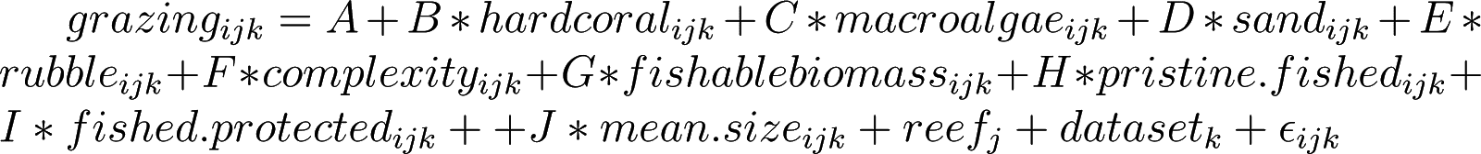](https://www.codecogs.com/eqnedit.php?latex=grazing_%7bijk%7d%20%3D%20A%20%2B%20B*hardcoral_%7bijk%7d%20%2B%20C*macroalgae_%7bijk%7d%20%2B%20D*sand_%7bijk%7d%20%2B%20E*rubble_%7bijk%7d%20%2B%20F*complexity_%7bijk%7d%20%2B%20G*fishablebiomass_%7bijk%7d%20%2B%20H*pristine.fished_%7bijk%7d%20%2B%20I*fished.protected_%7bijk%7d%20%2B%20%2B%20J*mean.size_%7bijk%7d%20%2B%20reef_j%20%2B%20dataset_k%20%2B%20\epsilon_%7bijk%7d%250) Eq. 8

From the global model, we fitted all possible subset models (Bartoń 2013) and assessed their support using Akaike’s Information Criterion (AIC), where the top-ranked model had the lowest AIC score (Burnham and Anderson 2003). We visualised relative covariate effect sizes by extracting standardised t-values for all models within 7 AIC units of the top-ranked model and, for each model, rescaling t-values so that 1 is the strongest predictor in a given model, and weighing that value by the models’ AIC weight (Cade 2015). These scaled t-values represent the relative effect size of each covariate between 0 (unimportant) and 1 (important). Next we generated model predictions to visualise the effect of each covariate with scaled t-value > 0.4, excluding remaining fixed effects and random effects and correcting predictions by each models’ AIC weight, with prediction uncertainty represented by the AIC-weighted sample variance (Robinson et al. 2017). Our multi-model approach accounts for uncertainty in the ‘best’ fitted model when AIC scores indicate several models are equally valid (Burnham and Anderson 2003). We avoid potential biases in model-averaged coefficient sizes by presenting effect sizes as standardised t-values, which are more informative measures of covariate importance than sums of AIC weights (Cade 2015).

We examined the dependency of grazing function on grazing biomass, abundance and assemblage composition. For each function, we fitted a linear mixed effects model between function ~ biomass, with random intercepts of reef nested within dataset and gamma distributed errors. Deviation from 1:1 relationships (i.e. decoupling) was evaluated with R2 values, whereby high R2 indicated a tight correlation between function and biomass/abundance and low R2 indicated decoupling of function from biomass. We further investigated decoupling by fitting a global linear mixed effects model, for each observation *i* at reef (*j*) in dataset (*k*) (nested random intercepts) and gamma distributed errors:

[](https://www.codecogs.com/eqnedit.php?latex=grazing_%7bijk%7d%20%3D%20A%20%2B%20B*biomass_%7bijk%7d%20%2B%20C*abundance_%7bijk%7d%20%2B%20D*rarefied.richness_%7bijk%7d%20%2B%20E*LCBD_%7bijk%7d%20%2B%20reef_j%20%2B%20dataset_k%20%2B%20\epsilon_%7bijk%7d%250) Eq. 9

This model allowed us to assess the influence of assemblage diversity and composition on function, while accounting for biomass and abundance effects. We fitted all subset models and weighed model support with AIC, and in this analysis, the top-ranked model was > 2 AIC units from other models, and thus covariate effect sizes and model predictions were interpreted directly from that model (Burnham and Anderson 2003).

All data were analysed in R (R Core Team 2018), using packages *iNext* (rarefaction; Hsieh et al. 2016), *lme4* (linear mixed effect models; Bates et al. 2015), *MuMIn* (multimodel inference; Bartoń 2013), *rethinking* (Bayesian models; McElreath 2017), and *vegan* (diversity estimates; Oksanen et al. 2017).

**Results**

Visual census data were integrated with *in situ* feeding observations for 131 reefs in four Indo-Pacific archipelagos. For cropping fishes, 9 species were assigned individual bite rates (32.9% of UVC biomass), and remaining species were assigned genera-specific (54.4%) or an average cropper bite rate (12.6%). Combined with herbivore? biomass, bite rates corresponded with estimated/modelled assemblage-level algal consumption rates ranging from 0.04 to 5.52 g ha-1 min-1, with grazing highest on GBR and Chagos reefs (Fig. S3A). Irrespective of region, algal consumption was maximised in complex habitats with high substrate availability and low macroalgal densities, while hard coral or rubble cover were weak influences (Fig. 1, 2A). Algal consumption rates were unaffected by fishing intensity, with remote, protected and fished reefs hosting similar cropping function potential (Fig. 1). Algal consumption did increase with average cropper size, indicating that reefs with cropper assemblages dominated by larger fishes had a higher grazing potential (Fig. 2B).

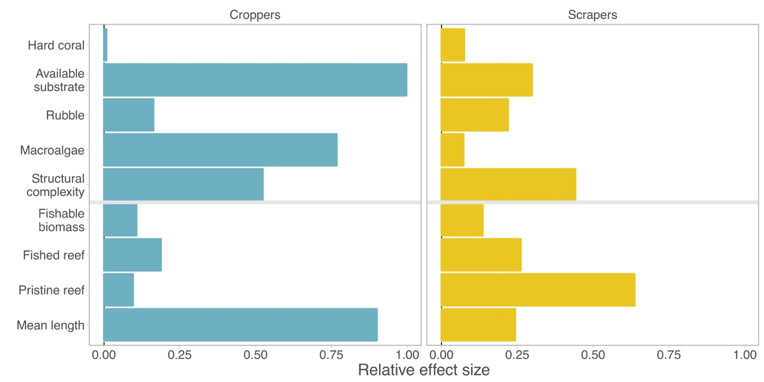

**Figure 1. Relative effect of benthic composition and fishing pressure on cropping and scraping rates.** Bars are relative effect size ratios of each covariate for top-ranking model sets (models ≤ 7 AIC units of top-ranked model), scaled to indicate very weak (0) or very important (1) drivers of grazing rates.

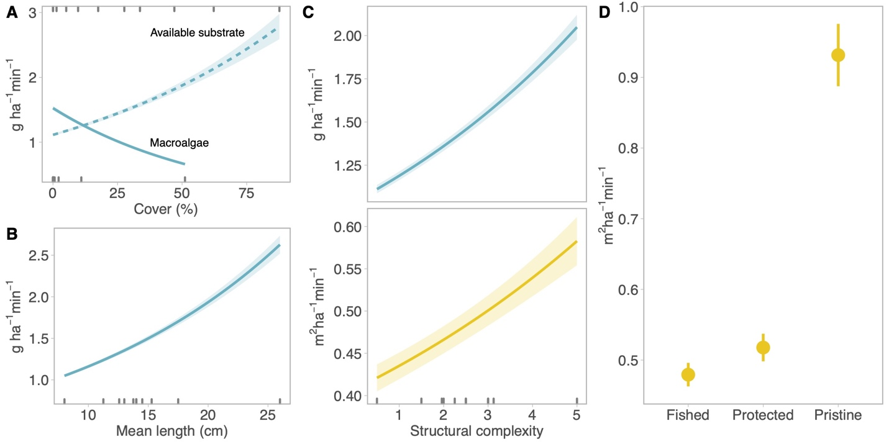

**Figure 2. Predicted effects of benthic and fishing drivers on cropper (A,B,C) and scraper (C,D) function.** Lines and points are herbivore functions as predicted by top model sets (≤ 7 AIC units from top-ranking model) holding other covariates to their means, with each model prediction weighted by its AIC weight and error represented as sample variance. All selected covariates had relative effect size ratios > 0.4 (Fig. 1). Decile rugs indicate the spread of observed data (in A, top rug is available substrate and bottom rug is macroalgae).

Feeding data were more highly resolved for scraping herbivores, with all fishes assigned size-based bite areas, and either species- (27 of 35 species, 80.9% of UVC) or genera-specific bite rates (19.1%). Potential area scraped was greatest on GBR reefs (> 1 m2 min-1 ha-1) and lowest on Maldives reefs (< 0.3 m2 min-1 ha-1) (Figure S4B). Scraping rates increased with structural complexity (Fig. 2C) but, in contrast to croppers, were relatively invariant across benthic cover covariates (Fig. 1). Remote reefs had the greatest scraping rates, which were considerably lower on fished reefs than protected ones (Figs. 1, 2D). After accounting for these coarse protection effects, scraping was only weakly associated with total fishable biomass and assemblage size structure (Fig. 1).

Grazing biomass is often used as a proxy for grazing function. Here, cropping function potential was strongly and positively correlated with cropper biomass (R2 = 0.83, Fig. 3A), indicating that the drivers of biomass variation would match tightly to the modelled drivers of cropper function. Scraping function potential also increased with scraping biomass, but with greater levels of unexplained variation in area scraped (m2 min-1 ha-1) (R2 = 0.55) which occurred across the full biomass gradient and in all four regions (Fig. 3B). We found that the remaining variation in both cropping and scraping rates was explained by biodiversity effects. For both groups, the addition of biodiversity covariates to grazing ~ biomass models improved predictive power (Table S3), indicating that decoupling of function from biomass was partially explained by differences in the identities and relative abundance of species among grazing assemblages. For croppers, grazing rates were moderately higher in speciose assemblages, and considerably lower for assemblages with high compositional dissimilarity (Fig. 4A,B). Scraping diversity relationships followed the same direction but changed in magnitude, with stronger richness effects and weaker composition effects (Fig. 4C,D). From the least to most speciose assemblages, richness effects produced a 21% increase in algal consumption and 76% increase in area scraped. In contrast, grazing was reduced by 95% (croppers) and 17% (scrapers) at sites where compositional dissimilarity was highest.

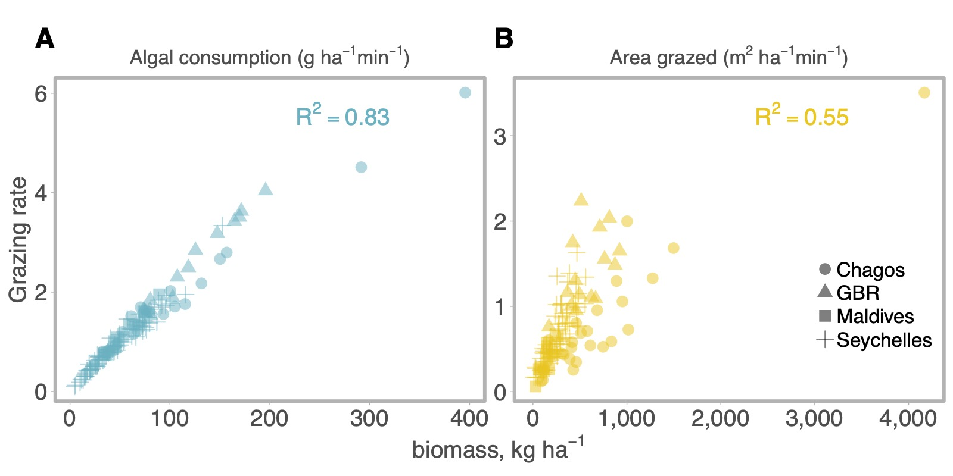

**Figure 3. Association between grazing function and grazing biomass.** Reef-level estimates of cropper algal consumption (A) and scraper area grazed (B) plotted against UVC biomass, with shapes indicating regions and labels indicating marginal R2 from a linear model of function ~ biomass.

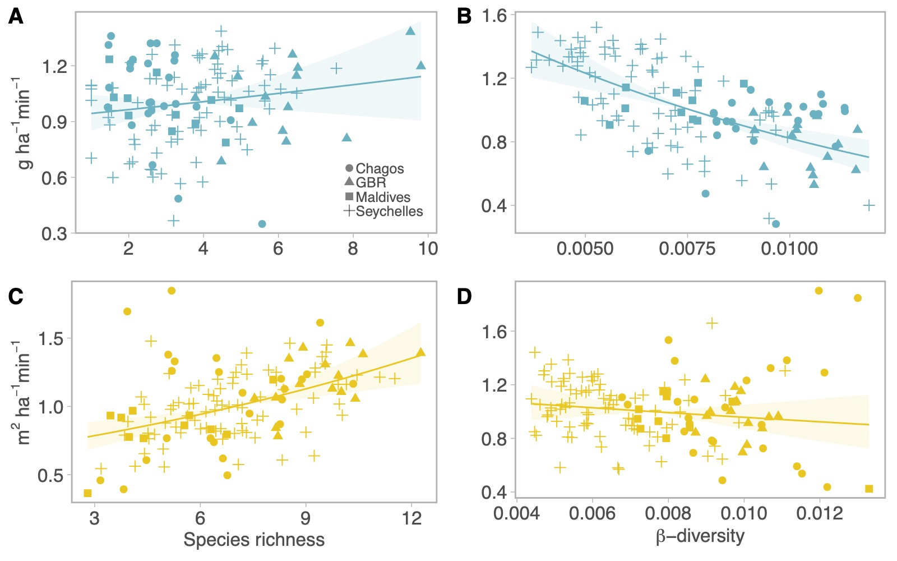

**Figure 4. Biodiversity effects on decoupling of herbivore function from herbivore biomass.** Lines are predicted effects of rarefied species richness (A,C) and β-diversity (LCBD) (B,D) on the grazing rates of croppers (blue) and scrapers (yellow) after accounting for biomass and abundance, shaded with two standard errors. Points are partial residuals for different regions.

**Discussion**

Herbivore functioning varied substantially across the Indo-Pacific in accordance with top-down (i.e. fishing pressure) and bottom-up (i.e. benthic habitat) drivers which were specific to each functional group. Small-bodied croppers were primarily controlled by bottom-up influences, with function maximised in complex habitats with high substrate availability and low macroalgae cover. Conversely, for parrotfishes, scraping was maximised on remote reefs in the Chagos archipelago which is isolated from fishing pressures, and was weakly associated with benthic habitat. After accounting for the strong dependency of grazing on fish biomass, we also identified biodiversity effects on grazing rates which demonstrate that variation in the number and relative abundance of species can alter grazing functions across large spatial scales.

Cropping rates were primarily mediated by benthic habitat type, in particular structural complexity, macroalgae cover, and substrate availability. Our results emphasize the strong dependence of small-bodied reef fishes on benthic composition (Munday and Jones 1998; Wilson et al. 2010), and demonstrate that top-down fishing effects do not affect cropping function, likely because croppers are small-bodied and not targeted in many reef-associated fisheries (Hicks & McClanahan 2012). Strong relationships between benthic composition and the grazing function of small-bodied reef fish may reflect the importance of resource availability, which has been shown to have stronger control on cropping surgeonfishes than fishing pressure (Russ et al. 2018). For example, the decrease in function with increasing macroalgae is likely because turf algae are less accessible to croppers under macroalgal canopies (Roff et al. 2015) whereas, on reefs with high substrate availability and limited macroalgae, expansive and easily accessible turf mats tend to support large grazer populations (Williams & Polunin 2001). Strong benthic effects imply that cropper functioning will respond more strongly to habitat disturbances, such as coral bleaching, habitat destruction or enrichment of algal communities, than to fishing. For example, disturbances which increase substrate availability for turf algal growth, such as coral mortality from heat stress (Gilmour et al. 2013), might therefore be expected to stimulate an increase in cropping function. However, since structural complexity was also shown to be a strong driver, any positive rebound of cropping function may be negated if disturbances also erode structural complexity (Graham et al. 2006).

Scraping function was strongly influenced by fishing pressure, which suppressed grazing rates far below those supported at remote wilderness reefs in the Chagos Archipelago. Our results further indicate that exploitation of large-bodied scrapers has compromised scraping functions on coral reefs (Bellwood et al. 2011). This effect superseded influences of benthic cover and small-scale fishing protection, suggesting that bottom-up control of scraping assemblages on reefs leads to minimal variation in their function, and that small-scale fishing protection does not conserve wilderness levels of scraping function. Movement of fish across reserve boundaries (Green et al. 2014) and poor compliance (Bergseth et al. 2018) likely limited the effectiveness of these small MPAs, many of which are adjacent to fishing grounds. Despite weak benthic cover effects, scraping rates increased moderately with structural complexity, further underlining the importance of coral reef structure in supporting herbivory (Nash et al. 2016).

Although total herbivore biomass was the strongest predictor of function for both croppers and scapers, remaining unexplained variation in function ~ biomass relationships was related to biodiversity effects. Positive effects of species richness on grazing rates, particularly for scrapers, are broadly consistent with recent coral reef studies which have uncovered positive biodiversity effects on herbivory (Lefcheck et al. 2019, Topor et al. 2019). The mechanisms underlying our results are, however, entirely different to those in small-scale experiments where biodiversity has been suggested to lead to feeding complementarity (Burkepile and Hay 2008, 2011) and intensifies grazing of individual fishes (Lefcheck et al. 2019, Topor et al. 2019). By focusing on benthic plots, these studies do not necessarily extrapolate to entire reefscapes where grazing pressure is dependent on the size of the resident fish assemblage, which itself is controlled by the availability of benthic habitat and historic fishing levels. Therefore, our approach of integrating feeding rates with UVC data enabled us to generate reef-level estimates of potential grazing pressure across a gradient of grazing biomass. At this scale, we confirm that more diverse reefs have higher potential grazing pressure. Here, however, β patterns contradict Lefcheck et al.’s (2019) finding that high species turnover raised grazing rates, likely because our LCBD estimates assessed turnover of species among distinct regional pools rather than among connected habitats. Across regional pools, we suggest that assemblages dominated by widely-distributed species have a lower grazing potential than those dominated by endemic species.

Biodiversity effects partially explained why grazing function decoupled from grazing biomass. Decoupling was strongest in scrapers, likely because all fishes were assigned species-, genera- and size-specific bite rates (Lokrantz et al. 2008) and so scraping estimates were more sensitive to changes in species diversity. In contrast, croppers were more tightly coupled to biomass levels, due to the absence of bite size data and to the high proportion of individual fishes which were assigned average grazing rates. Indeed, we note that our definitions of grazing functions were limited by our generalisation across species with similar functions but different feeding modes. This may have been particularly problematic for cropping species which have well-documented differences in morphology, diet (e.g. detritivores or turf), and feeding behaviours (Choat et al. 2002, Brandl et al. 2015, Tebbett et al. 2017). Nevertheless, the modelling framework we used to generate grazing estimates is a significant improvement on the procedure employed by previous macroscale grazing studies (e.g. Bellwood et al. 2011). By modelling genera- and species-specific bite rates from observations collected in several regions, we were able to leverage observational data in a hierarchical framework which predicts grazing rates of new, related species, given uncertainties in species, genera and body sizes. For example, we were able to assign bite rates to species observed in UVC but not observed in feeding surveys, with estimates that were informed by the feeding behaviour of closely related congeners. Such models could be further improved with additional feeding data on other herbivore species in different regions, and could even be developed to account for temperature controls on grazing rates (Bruno et al. 2015) that might confound comparisons of herbivory across temperature regimes.

The random intercepts in our predictive models indicated that regional similarities in grazing rates were unexplained by benthic, fishing and biodiversity covariates, which is likely due to unmeasured processes that control herbivore biomass. For example, herbivore biomass variation (and thus grazing function) has been linked to differences in oceanic productivity (Heenan et al. 2016) while video observations indicate that grazing intensity is constrained by wave exposure (Bejarano et al. 2017). Similarly, long-term studies of frequently perturbed coral reefs indicate that grazing assemblages continually reorganize in response to disturbance (Han et al. 2016), implying that grazing intensity will respond in similar non-linear trajectories. Temporal analyses linking habitat suitability, primary productivity, and herbivory would greatly develop our understanding of how herbivory rates influence long-term changes in reef state.

Our study demonstrates how benthic habitat, fishing pressure and biodiversity influence the functional potential of herbivore assemblages at scales which are relevant for understanding ecosystem-level responses to disturbances such as bleaching (Nash et al. 2016). Cropping pressure is likely to increase in response to stressors which clear substrate space for turf growth. Intact reef structure will be critical for maintenance of scraping functions, though inhabited reefs are unlikely to return to wilderness levels of grazing pressure, even with protection from fishing. For a given level of biomass, protection of biodiversity will enhance grazing, but differences in regional pools mean that grazing potential of fish assemblages may vary naturally among reefs. We stress that biomass was by far the most important predictor of scraping function, and recovery or protection of fish biomass will help ensure herbivory processes are functionally intact on degraded coral reefs (Williams et al. 2016).

**Acknowledgements**

Data? Grants? funded by the Australian Research Council to ASH (DE130100688), Lizard Island Reef Research Foundation Doctoral Fellowship (AGL)

[**Supplementary Material**](https://github.com/jpwrobinson/grazing-gradients/blob/master/writing/ms/supp-material.pdf)

**References**

Arnold SN, Steneck RS, Mumby PJ (2010) Running the gauntlet: inhibitory effects of algal turfs on the processes of coral recruitment. Mar Ecol Prog Ser 414:91–105

Bartoń K (2013) MuMIn: multi-model inference. R package version 1:18

Bates D, Maechler M, Bolker B, Walker S (2015) Fitting linear mixed-effects models using lme4. J Stat Softw 67:1–48

Bejarano, S., Jouffray, J.-B., Chollett, I., Allen, R., Roff, G., Marshell, A., … Mumby, P. J. (2017). The shape of success in a turbulent world: wave exposure filtering of coral reef herbivory. *Functional Ecology*, *31*(6), 1312–1324.

Bellwood DR, Choat JH (1990) A functional analysis of grazing in parrotfishes (family Scaridae): the ecological implications. Environ Biol Fishes 28:189–214

Bellwood DR, Hoey AS, Choat JH (2003) Limited functional redundancy in high diversity systems: resilience and ecosystem function on coral reefs. Ecol Lett 6:281–285

Bellwood DR, Hoey AS, Hughes TP (2011) Human activity selectively impacts the ecosystem roles of parrotfishes on coral reefs. Proc Biol Sci 279:1621–1629

Bellwood DR, Hughes TP, Folke C, Nyström M (2004) Confronting the coral reef crisis. Nature 429:827–833

Bergseth, B. J., Gurney, G. G., Barnes, M. L., Arias, A., & Cinner, J. E. (2018). Addressing poaching in marine protected areas through voluntary surveillance and enforcement. *Nature Sustainability*, *1*(8), 421–426.

Best RJ, Chaudoin AL, Bracken MES, Graham MH, Stachowicz JJ (2014) Plant–animal diversity relationships in a rocky intertidal system depend on invertebrate body size and algal cover. Ecology 95:1308–1322

Bonaldo RM, Bellwood DR (2008) Size-dependent variation in the functional role of the parrotfish Scarus rivulatus on the Great Barrier Reef, Australia. Mar Ecol Prog Ser 360:237–244

Bonaldo, R. M., & Hoey, A. S. (2014). The ecosystem roles of parrotfishes on tropical reefs. *Oceanography and Marine Biology: An Annual Review*, *52*, 81–132.

Brandl, S. J., Robbins, W. D., & Bellwood, D. R. (2015). Exploring the nature of ecological specialization in a coral reef fish community: morphology, diet and foraging microhabitat use. *Proceedings. Biological Sciences / The Royal Society*, *282*(1815), 20151147.

Bruno JF, Carr LA, O’Connor MI (2015) Exploring the role of temperature in the ocean through metabolic scaling. Ecology 96:3126–3140

Burkepile DE, Hay ME (2008) Herbivore species richness and feeding complementarity affect community structure and function on a coral reef. Proc Natl Acad Sci U S A 105:16201–16206

Burkepile DE, Hay ME (2011) Feeding complementarity versus redundancy among herbivorous fishes on a Caribbean reef. Coral Reefs 30:351–362

Burnham KP, Anderson DR (2003) Model Selection and Multimodel Inference: A Practical Information-Theoretic Approach. Springer Science & Business Media, New York

Cade BS (2015) Model averaging and muddled multimodel inference. Ecology 96:2370–2382

Chao A, Jost L (2012) Coverage-based rarefaction and extrapolation: standardizing samples by completeness rather than size. Ecology 93:2533–2547

Cheal AJ, MacNeil MA, Cripps E, Emslie MJ, Jonker M, Schaffelke B, Sweatman H (2010) Coral–macroalgal phase shifts or reef resilience: links with diversity and functional roles of herbivorous fishes on the Great Barrier Reef. Coral Reefs 29:1005–1015

Choat, J. H., & Clements, K. D. (2018). Nutritional ecology of parrotfishes (Scarinae, Labridae). In *Biology of parrotfishes* (pp. 42-68). CRC Press.

Choat J, Clements K, Robbins W (2002) The trophic status of herbivorous fishes on coral reefs. Mar Biol 140:613–623

Doropoulos C, Hyndes GA, Abecasis D, Vergés A (2013) Herbivores strongly influence algal recruitment in both coral- and algal-dominated coral reef habitats. Mar Ecol Prog Ser 486:153–164

Doropoulos C, Ward S, Marshell A, Diaz-Pulido G, Mumby PJ (2012) Interactions among chronic and acute impacts on coral recruits: the importance of size-escape thresholds. Ecology 93:2131–2138

Duffy JE, Lefcheck JS, Stuart-Smith RD, Navarrete SA, Edgar GJ (2016) Biodiversity enhances reef fish biomass and resistance to climate change. Proc Natl Acad Sci U S A 113:6230–6235

Edwards CB, Friedlander AM, Green AG, Hardt MJ, Sala E, Sweatman HP, Williams ID, Zgliczynski B, Sandin SA, Smith JE (2014) Global assessment of the status of coral reef herbivorous fishes: evidence for fishing effects. Proc Biol Sci 281:20131835

Froese R, Pauly D (2018) FishBase.

Gilmour JP, Smith LD, Heyward AJ, Baird AH, Pratchett MS (2013) Recovery of an isolated coral reef system following severe disturbance. Science 340:69–71

Graham NAJ, Jennings S, MacNeil MA, Mouillot D, Wilson SK (2015) Predicting climate-driven regime shifts versus rebound potential in coral reefs. Nature 518:94–97

Graham NAJ, McClanahan TR (2013) The Last Call for Marine Wilderness? Bioscience 63:397–402

Graham, N. A. J., Wilson, S. K., Jennings, S., Polunin, N. V. C., Bijoux, J. P., & Robinson, J. (2006). Dynamic fragility of oceanic coral reef ecosystems. *Proceedings of the National Academy of Sciences of the United States of America*, *103*(22), 8425–8429.

Green AL, Bellwood DR (2009) Monitoring functional groups of herbivorous reef fishes as indicators of coral reef resilience - A practical guide for coral reef managers in the Asia Pacific region.

Green, A. L., Maypa, A. P., Almany, G. R., Rhodes, K. L., Weeks, R., Abesamis, R. A., … White, A. T. (2014). Larval dispersal and movement patterns of coral reef fishes, and implications for marine reserve network design. *Biological Reviews of the Cambridge Philosophical Society*, *90*(4), 1215–1247.

Han, X., Adam, T. C., Schmitt, R. J., Brooks, A. J., & Holbrook, S. J. (2016). Response of herbivore functional groups to sequential perturbations in Moorea, French Polynesia. *Coral Reefs* , *35*(3), 999–1009.

Heenan A, Hoey AS, Williams GJ, Williams ID (2016) Natural bounds on herbivorous coral reef fishes. Proc Biol Sci 283:20161716

Hicks, C. C., & McClanahan, T. R. (2012). Assessing gear modifications needed to optimize yields in a heavily exploited, multi-species, seagrass and coral reef fishery. *PloS One*, *7*(5), e36022.

Hoey AS, Bellwood DR (2008) Cross-shelf variation in the role of parrotfishes on the Great Barrier Reef. Coral Reefs 27:37–47

Howard Choat J, Robbins WD, Clements KD (2004) The trophic status of herbivorous fishes on coral reefs. Mar Biol 145:445–454

Hsieh TC, Ma KH, Chao A (2016) iNEXT: an R package for rarefaction and extrapolation of species diversity (Hill numbers). Methods Ecol Evol 7:1451–1456

Hughes TP, Rodrigues MJ, Bellwood DR, Ceccarelli D, Hoegh-Guldberg O, McCook L, Moltschaniwskyj N, Pratchett MS, Steneck RS, Willis B (2007) Phase shifts, herbivory, and the resilience of coral reefs to climate change. Curr Biol 17:360–365

Jouffray J-B, Nyström M, Norström AV, Williams ID, Wedding LM, Kittinger JN, Williams GJ (2015) Identifying multiple coral reef regimes and their drivers across the Hawaiian archipelago. Philos Trans R Soc Lond B Biol Sci 370:20130268

Keesing F, Young TP (2014) Cascading Consequences of the Loss of Large Mammals in an African Savanna. Bioscience 64:487–495

Ledlie MH, Graham NAJ, Bythell JC, Wilson SK, Jennings S, Polunin NVC, Hardcastle J (2007) Phase shifts and the role of herbivory in the resilience of coral reefs. Coral Reefs 26:641–653

Legendre, P., & De Cáceres, M. (2013). Beta diversity as the variance of community data: dissimilarity coefficients and partitioning. *Ecology Letters*, *16*(8), 951–963.

Lokrantz J, Nyström M, Thyresson M, Johansson C (2008) The non-linear relationship between body size and function in parrotfishes. Coral Reefs 27:967–974

Marshell A, Mumby PJ (2015) The role of surgeonfish (Acanthuridae) in maintaining algal turf biomass on coral reefs. J Exp Mar Bio Ecol 473:152–160

McClanahan TR, Maina JM, Graham NAJ, Jones KR (2016) Modeling Reef Fish Biomass, Recovery Potential, and Management Priorities in the Western Indian Ocean. PLoS One 11:e0154585

McElreath R (2017) Rethinking: statistical Rethinking book package. R package version 1:

Metcalfe DB, Asner GP, Martin RE, Silva Espejo JE, Huasco WH, Farfán Amézquita FF, Carranza-Jimenez L, Galiano Cabrera DF, Baca LD, Sinca F, Huaraca Quispe LP, Taype IA, Mora LE, Dávila AR, Solórzano MM, Puma Vilca BL, Laupa Román JM, Guerra Bustios PC, Revilla NS, Tupayachi R, Girardin CAJ, Doughty CE, Malhi Y (2014) Herbivory makes major contributions to ecosystem carbon and nutrient cycling in tropical forests. Ecol Lett 17:324–332

Mumby PJ, Dahlgren CP, Harborne AR, Kappel CV, Micheli F, Brumbaugh DR, Holmes KE, Mendes JM, Broad K, Sanchirico JN, Buch K, Box S, Stoffle RW, Gill AB (2006) Fishing, trophic cascades, and the process of grazing on coral reefs. Science 311:98–101

Munday PL, Jones GP (1998) The Ecological Implications of Small Body Size Among Coral-Reef Fishes. Ocean Coast Manag 36:373–411

Nash KL, Graham NAJ, Bellwood DR (2013) Fish foraging patterns, vulnerability to fishing, and implications for the management of ecosystem function across scales. Ecol Appl 23:1632–1644

Nash KL, Graham NAJ, Jennings S, Wilson SK, Bellwood DR (2016) Herbivore cross-scale redundancy supports response diversity and promotes coral reef resilience. J Appl Ecol 53:646–655

Nash, K. L., Abesamis, R. A., Graham, N. A. J., McClure, E. C., & Moland, E. (2016). Drivers of herbivory on coral reefs: species, habitat and management effects. *Marine Ecology Progress Series*, *554*, 129–140.

Oksanen J, Guillaume Blanchet F, Friendly M, Kindt R, Legendre P, McGlinn D, Minchin PR, O’Hara RB, Simpson GL, Solymos P, Stevens MHH, Szoecs E, Wagner H (2017) vegan: Community Ecology Package. R package ersion 2.4-4:

Polunin NVC, Harmelin-Vivien M, Galzin R (1995) Contrasts in algal food processing among five herbivorous coral-reef fishes. J Fish Biol 47:455–465

Polunin NVC, Roberts CM (1993) Greater biomass and value of target coral-reef fishes in two small Caribbean marine reserves. Marine Ecology-Progress Series 100:167–167

Robinson JPW, Williams ID, Edwards AM, McPherson J, Yeager L, Vigliola L, Brainard RE, Baum JK (2017) Fishing degrades size structure of coral reef fish communities. Glob Chang Biol 23:1009–1022

Robinson JPW, Williams ID, Yeager LA, McPherson JM, Clark J, Oliver TA, Baum JK (2018) Environmental conditions and herbivore biomass determine coral reef benthic community composition: implications for quantitative baselines. Coral Reefs

Rooij JM, Videler JJ, Bruggemann JH (1998) High biomass and production but low energy transfer efficiency of Caribbean parrotfish: implications for trophic models of coral reefs. J Fish Biol 53:154–178

Royo AA, Collins R, Adams MB, Kirschbaum C, Carson WP (2010) Pervasive interactions between ungulate browsers and disturbance regimes promote temperate forest herbaceous diversity. Ecology 91:93–105

Prieditis, A., Howlett, S.J., Baumanis, J., Bagrade, G., Done, G., Jansons, A., Neimane, U., Ornicans, A., Stepanova, A., Smits, A. and Zunna, A., 2017. Quantification of Deer Browsing in Summer and Its Importance for Game Management in Latvia. *Baltic Forestry*, *23*(2), pp.423-431.

Russ GR, Questel S-LA, Rizzari JR, Alcala AC (2015) The parrotfish–coral relationship: refuting the ubiquity of a prevailing paradigm. Mar Biol 162:2029–2045

Samoilys MA, Carlos G (2000) Determining Methods of Underwater Visual Census for Estimating the Abundance of Coral Reef Fishes. Environ Biol Fishes 57:289–304

Schielzeth H (2010) Simple means to improve the interpretability of regression coefficients: Interpretation of regression coefficients. Methods Ecol Evol 1:103–113

Tebbett, S. B., Goatley, C. H. R., & Bellwood, D. R. (2017). Clarifying functional roles: algal removal by the surgeonfishes Ctenochaetus striatus and Acanthurus nigrofuscus. *Coral Reefs* , *36*(3), 803–813.

Williams, I., & Polunin, N. (2001). Large-scale associations between macroalgal cover and grazer biomass on mid-depth reefs in the Caribbean. *Coral Reefs* , *19*(4), 358–366.

Wilson, S. K., Fisher, R., Pratchett, M. S., Graham, N. A. J., Dulvy, N. K., Turner, R. A., … Rushton, S. P. (2008). Exploitation and habitat degradation as agents of change within coral reef fish communities. *Global Change Biology*, *14*(12), 2796–2809.

Wilson SK, Fisher R, Pratchett MS, Graham NAJ, Dulvy NK, Turner RA, Cakacaka A, Polunin NVC (2010) Habitat degradation and fishing effects on the size structure of coral reef fish communities. Ecol Appl 20:442–451

Wilson SK, Graham NAJ, Polunin NVC (2007) Appraisal of visual assessments of habitat complexity and benthic composition on coral reefs. Mar Biol 151:1069–1076

Yarlett RT, Perry CT, Wilson RW, Philpot KE (2018) Constraining species-size class variability in rates of parrotfish bioerosion on Maldivian coral reefs: implications for regional-scale bioerosion estimates. Mar Ecol Prog Ser 590:155–169

Zimov SA, Chuprynin VI, Oreshko AP, Chapin FS, Reynolds JF, Chapin MC (1995) Steppe-Tundra Transition: A Herbivore-Driven Biome Shift at the End of the Pleistocene. Am Nat 146:765–794